Task:1

Printing Stars

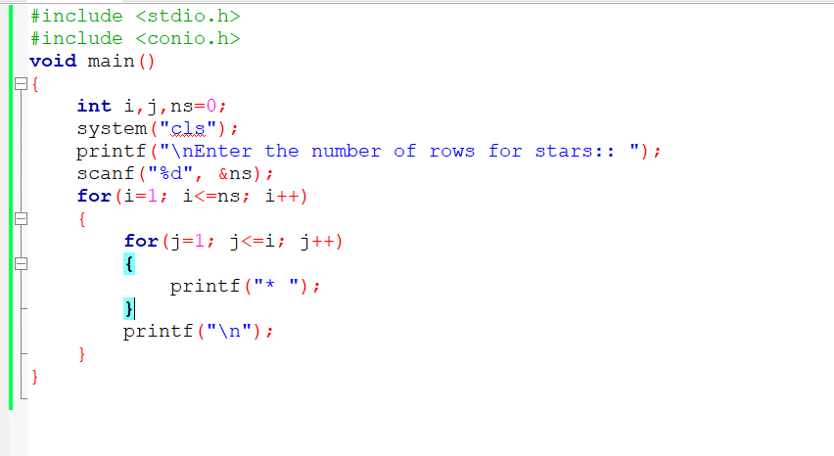

Output:

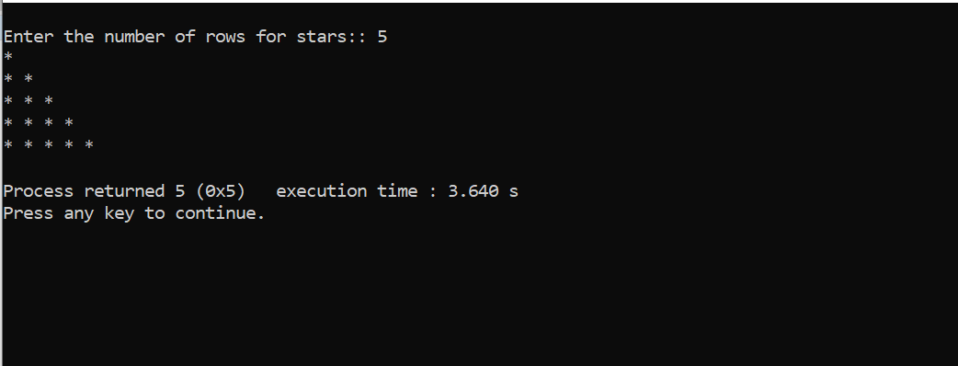

Task:2

Matrix

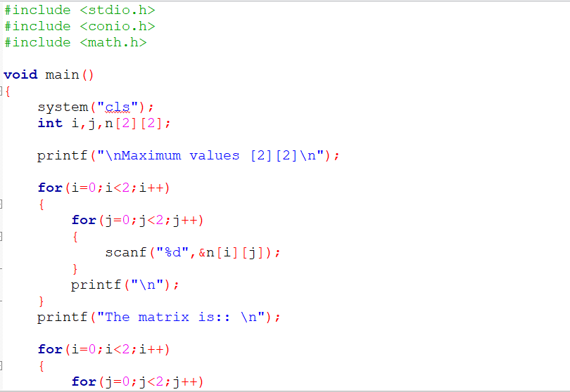

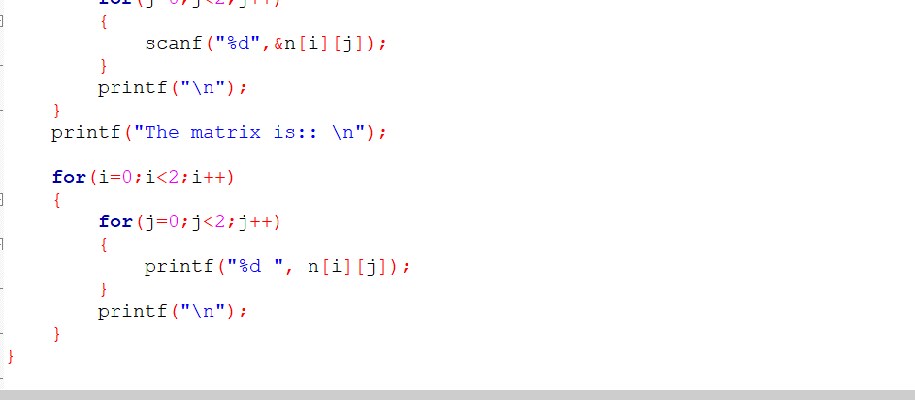

Output:

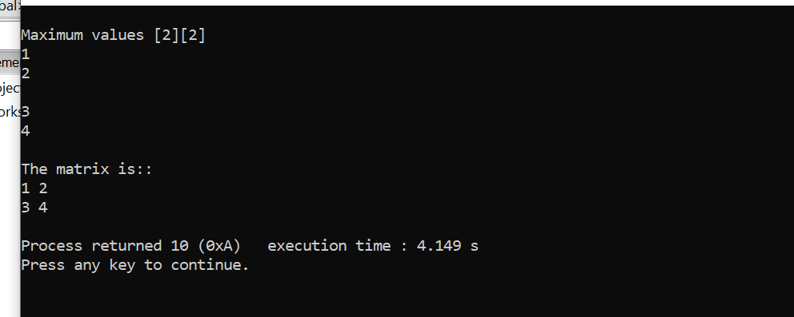

Task:3

Matrix Multiplication

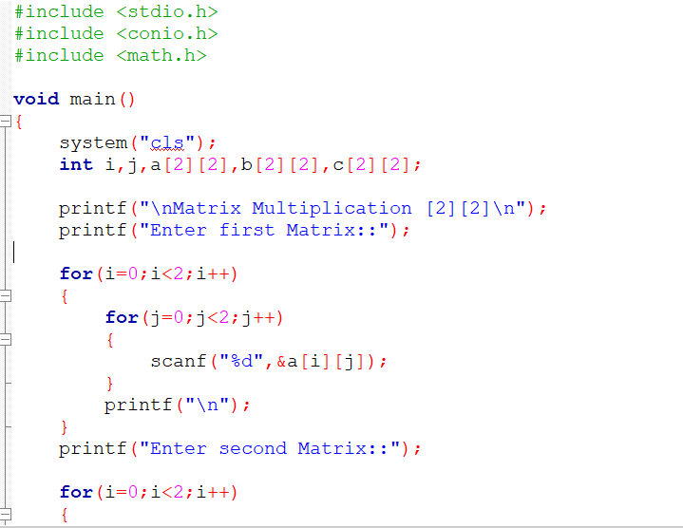

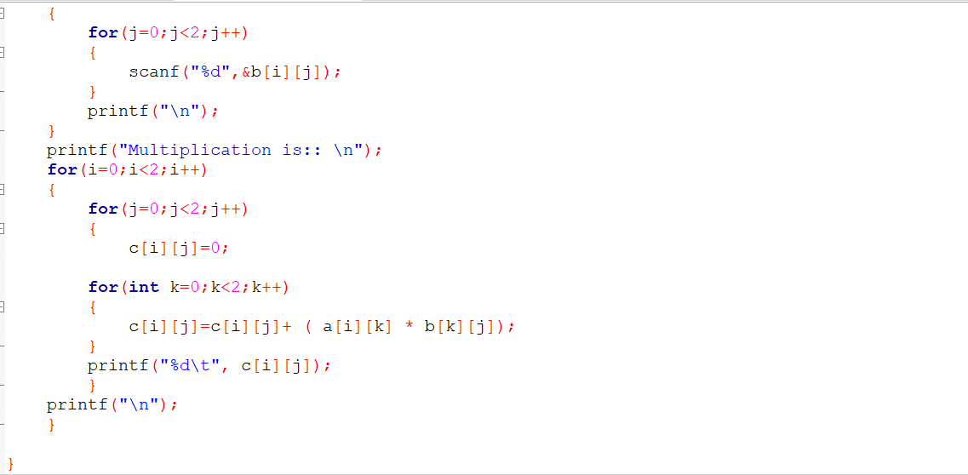

Output:

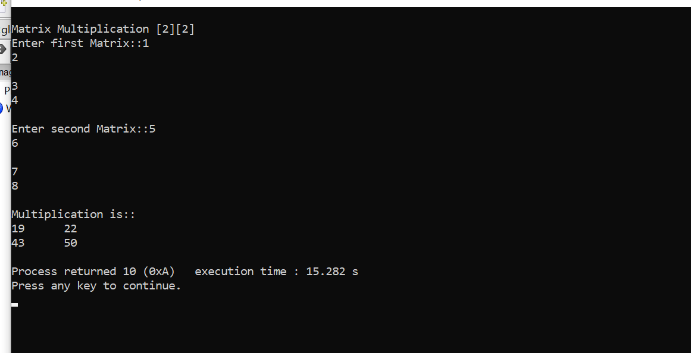

Task: 4

Fibonacci Series

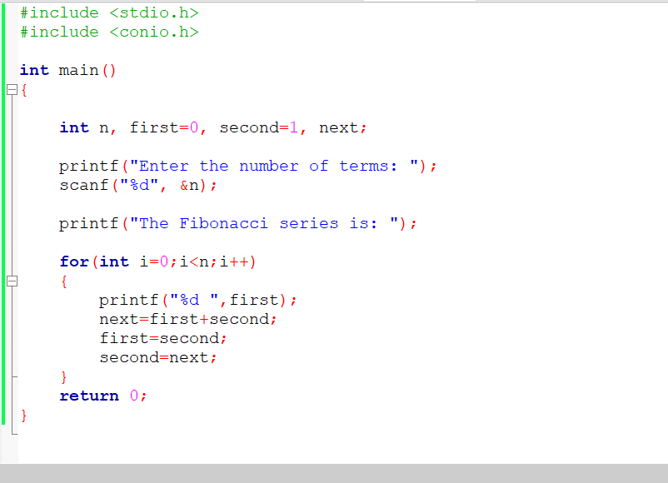

Output:

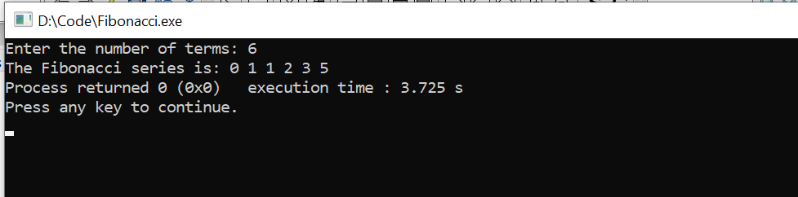

Task: 5

Factorial

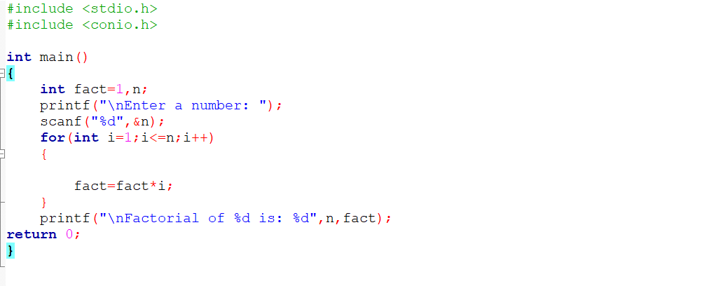

Output:

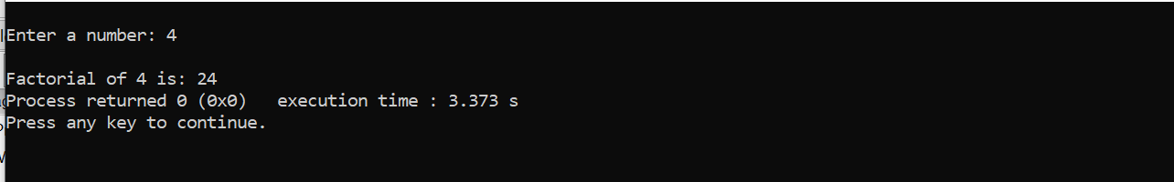

Task:6

Do While Loop

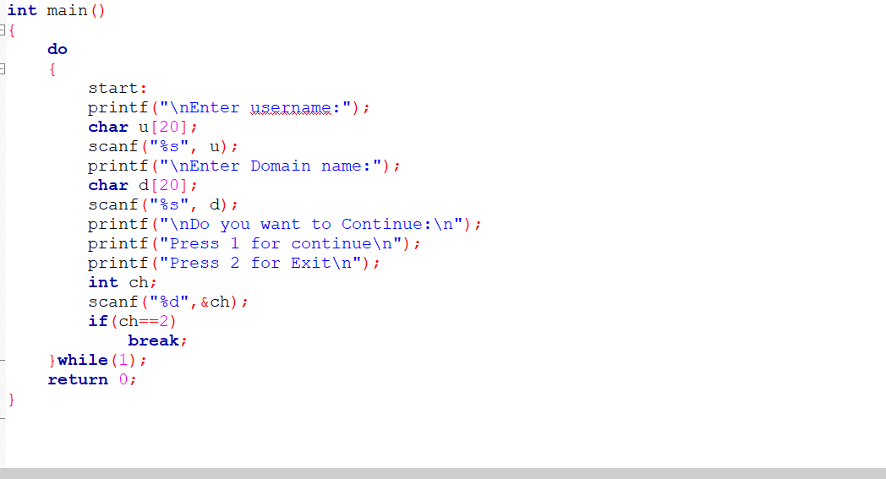

Output:

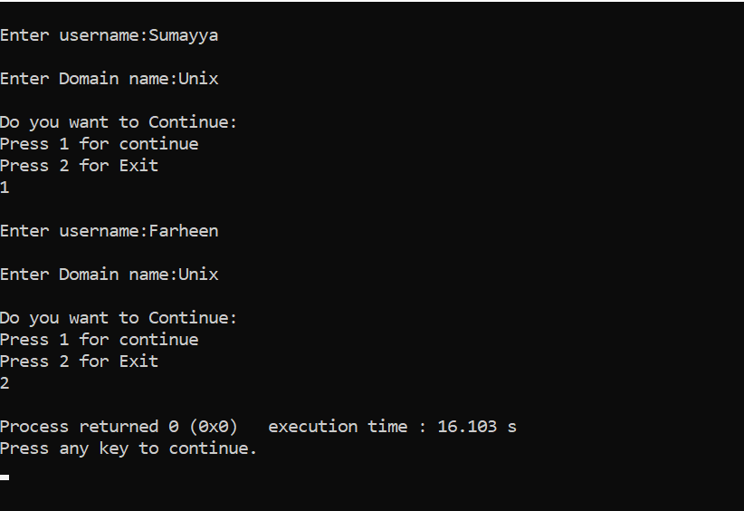

Task:7

While Loop

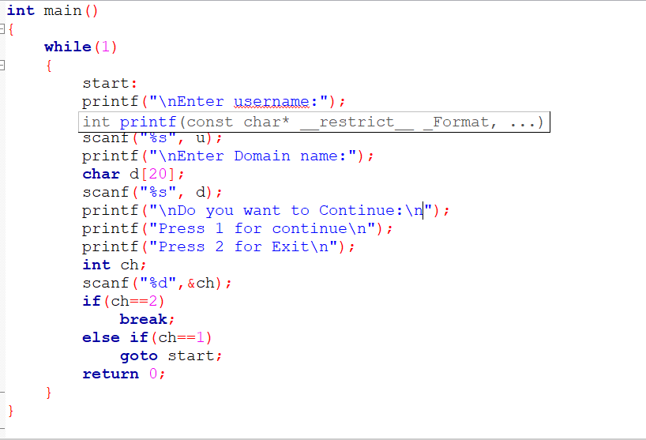

Output:

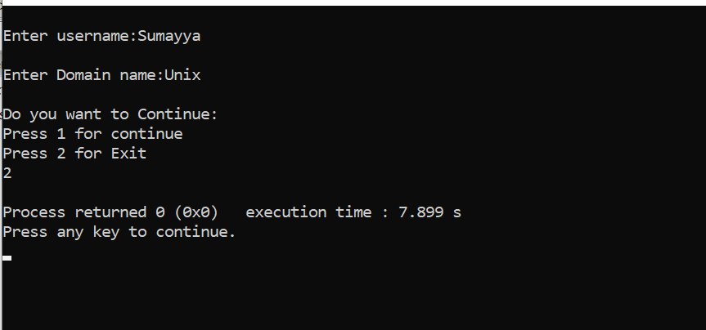

Task: 8

a[20] , take the input from user

#include <stdio.h>

void main()

{

int a[20];

printf("Enter 20 elements:\n");

for(int i=0;i<20;i++)

{

printf("Enter element %d: ",i+1);

scanf("%d", &a[i]);

}

printf("\nEntered elements:\n");

for(int i=0; i<20; i++)

{

printf("%d ",a[i]);

}

printf("\n");

}

Output:

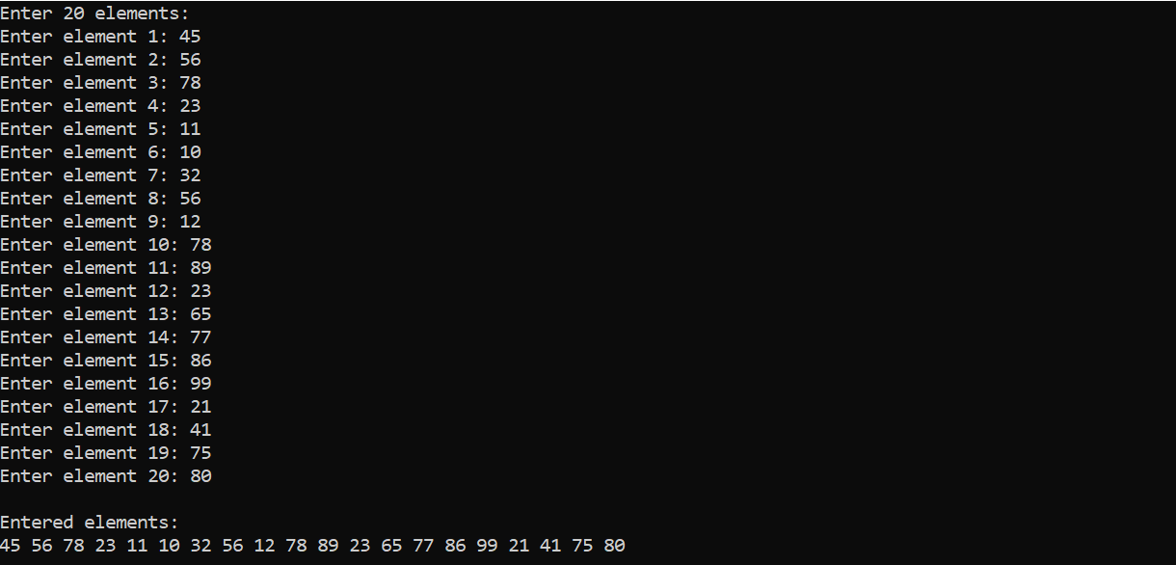

Task:9

print all the elements pf a[20] with their Index values

#include <stdio.h>

void main()

{

int a[20];

printf("Enter 20 elements:\n");

for(int i=0;i<20;i++)

{

printf("Enter element %d: ",i+1);

scanf("%d", &a[i]);

}

printf("\nEntered elements:\n");

for(int i=0; i<20; i++)

{

printf("Index %d: %d\n",i,a[i]);

}

printf("\n");

}

Output:

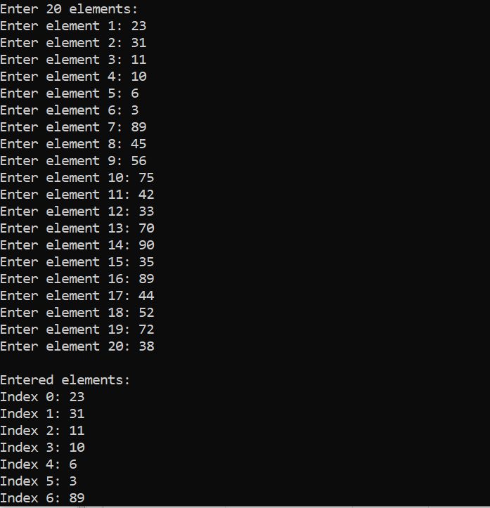

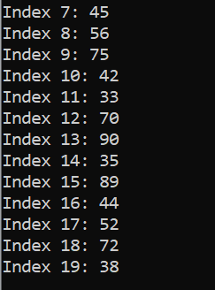

Task: 10

Delete a particular elemenet from an array, a[15]

#include <stdio.h>

void main()

{

int a[20],j;

printf("Enter 20 elements:\n");

for(int i=0;i<20;i++)

{

printf("Enter element %d: ",i+1);

scanf("%d", &a[i]);

}

printf("\nEnter the index value that is to be deleted: ");

scanf("%d",&j);

a[j]=0;

printf("\nThe elements of the array after deletion: \n");

for(int i=0;i<20;i++)

{

printf("%d ",a[i]);

}

}

Output:

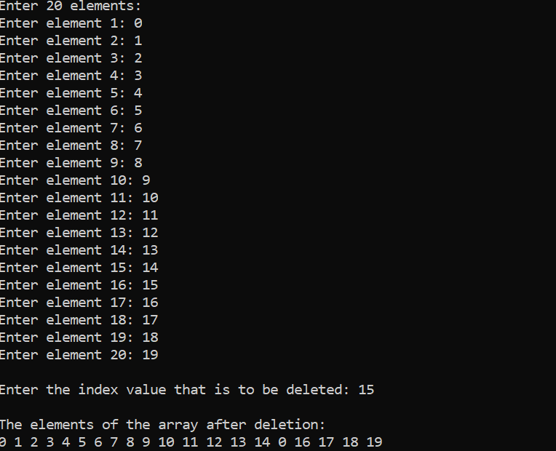

Task: 11

Find if there s any duplicates in a[20]

#include <stdio.h>

void main()

{

int a[20];

printf("Enter 20 elements:\n");

for(int i=0;i<20;i++)

{

scanf("%d", &a[i]);

}

printf("\nPrint index values of the duplicate elements: \n");

for(int i=0;i<20;i++)

{

for(int j=i+1;j<20;j++)

{

if(a[i]==a[j])

{

printf("%d and %d\n",i,j);

}

}

}

}

Output:

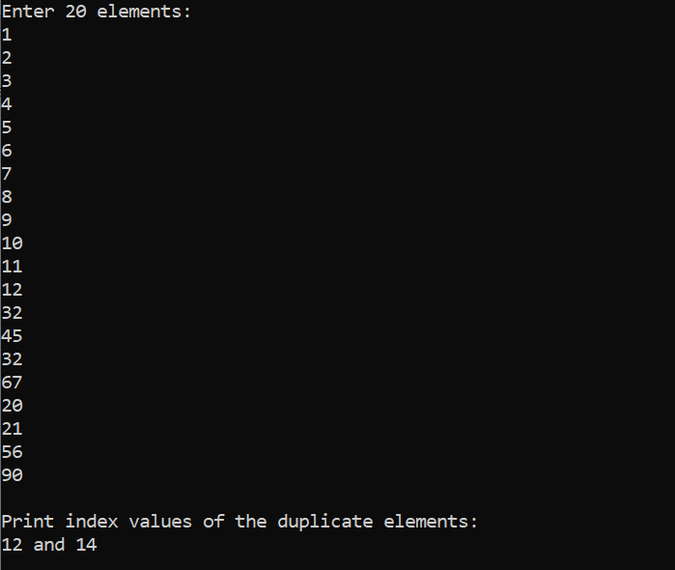

Task: 12

search [10] from a[20]

#include <stdio.h>

void main()

{

int a[20],n,flag=0;

printf("Enter 20 elements:\n");

for(int i=0;i<20;i++)

{

scanf("%d", &a[i]);

}

printf("\nEnter the element that is to be searched: \n");

scanf("%d",n);

for(int i=0;i<20;i++)

{

if(a[i]==n)

{

printf("\nThe given number %d is found at the index value: %d",i);

flag++;

}

}

if(flag==0)

{

printf("Element not found");

}

}

Output:

